**R N S INSTITUTE OF TECHNOLOGY**

**DEPARTMENTOF MATHEMATICS**

**Channasandra, Bangalore- 560 098**



**STUDY MATERIALS**

**FOR 15MAT11**

**VECTOR CALCULUS**

**VTU NEW SYLLABUS**

**MODULE-3**

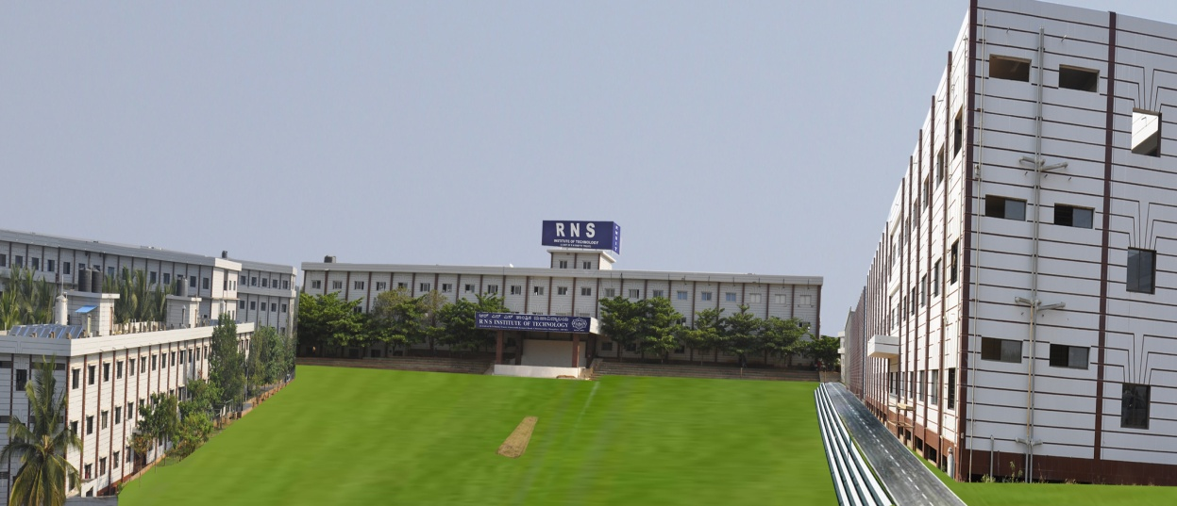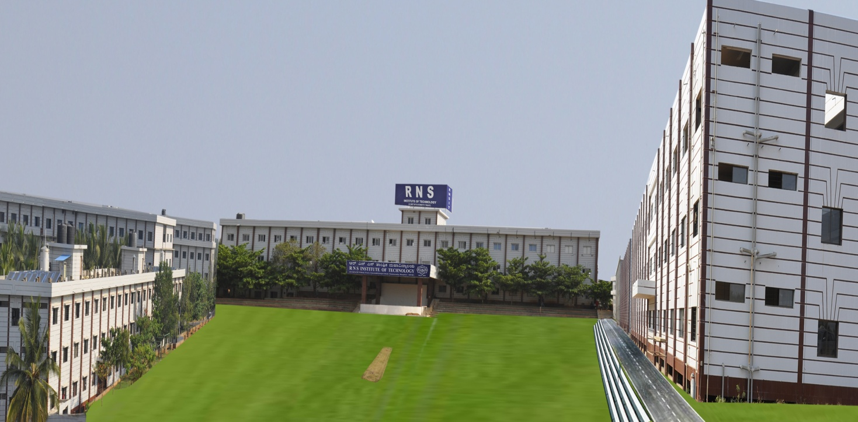

Module-3 Vector Differentiation

Syllabus Vector Calculus:

Derivative of vector valued functions are Velocity, Acceleration and related problems, Scalar and Vector point functions. Definition of Gradient, Divergence and curl-problems. Solenoidal and Irrotational Vector fields. Vector identities-.

Synopsis

* Vector Differentiation

1.  2. Derivative of r 

3. If  is a scalar function and  is a vector function, then



4.   are scalar constants and  are vector   
 functions

5.   are vector functions.

6. .

7.   are vector functions.

8.     
 are vector functions.

9. The magnitude of a vector function  is constant if and only if 

10. The direction of a non-zero vector function  is constant (fixed) if and only   
 if 

11. Let  be a constant vector(both magnitude and direction are fixed) function of   
 the scalar variable t, then .

12.  is the vector equation of the curve C.

13. .

14. 

15. 

16. tangential component of the acceleration

is the normal component of acceleration.

17. .

18. If f and g are scalar point function, then 

Or 

19.  or 

20.  or 

21. vector 

22. 

23. Directional derivative of  along  is 

Directional derivative of  along  is 

24. If  is a vector point function then divergence of  is



25. If  then the vector is said to be Solenoidal vector.

.

26. If  is a vector point function then curl of  is

 

27. If the vector  is irrotational vector then 

28. A vector point function  is said to be a conservative vector if there exists a scalar function  such that . Then  is called a scalar potential of .

3.0 Introduction

Vector Calculus is a field of mathematics concerned with multivariate real analysis of vectors in two or more dimensions. It consists of a set of formulas and problems solving techniques very useful for Engineering and physics.

In Vector calculus three important operators are discussed.

* Gradient: Measures the rate and direction of change in a scalar field; the gradient of a scalar field is a vector field.
* Divergence: Measures a vector field’s tendency to originate from or convergence upon a given point.
* Curl: Measures a vector field’s tendency to rotate about a point; the curl of a vector field is another vector field.

Vector Calculus can be applied in numerous fields

1) Defining cylinders and quadratic surfaces in 3D space

2) Modelling projectile motion

3) Used to find centre of mass, moment of inertia, radius of gyration.

4) It is used in field theory

5) It is used in Maxwell’s equation

6) It is used in kinematics.

7) Majorly used in Electromagnetic Field Theory in Electrical based branches.

8) Used in fluid and aerodynamics.

Vector calculus was developed from [quaternion](https://en.wikipedia.org/wiki/Quaternion) analysis by [J. Willard Gibbs](https://en.wikipedia.org/wiki/J._Willard_Gibbs) and [Oliver Heaviside](https://en.wikipedia.org/wiki/Oliver_Heaviside) near the end of the 19th century, and most of the notation and terminology was established by Gibbs and [Edwin Bidwell Wilson](https://en.wikipedia.org/wiki/Edwin_Bidwell_Wilson) in their 1901 book, [*Vector Analysis*](https://en.wikipedia.org/wiki/Vector_Analysis).

Josiah Willard Gibbs was an American scientist who made important theoretical contributions to physics, chemistry, and mathematics. His work on the applications of [thermodynamics](https://en.wikipedia.org/wiki/Thermodynamics) was instrumental in transforming [physical chemistry](https://en.wikipedia.org/wiki/Physical_chemistry) into a rigorous inductive science. Together with [James Clerk Maxwell](https://en.wikipedia.org/wiki/James_Clerk_Maxwell) and [Ludwig Boltzmann](https://en.wikipedia.org/wiki/Ludwig_Boltzmann), he created [statistical mechanics](https://en.wikipedia.org/wiki/Statistical_mechanics) (a term that he coined), explaining the [laws of thermodynamics](https://en.wikipedia.org/wiki/Laws_of_thermodynamics) as consequences of the statistical properties of [ensembles](https://en.wikipedia.org/wiki/Statistical_ensemble_(mathematical_physics)) of the possible states of a physical system composed of many particles. Gibbs also worked on the application of [Maxwell's equations](https://en.wikipedia.org/wiki/Maxwell%27s_equations) to problems in [physical optics](https://en.wikipedia.org/wiki/Physical_optics). As a mathematician, he invented modern [vector calculus](https://en.wikipedia.org/wiki/Vector_calculus) (independently of the British scientist [Oliver Heaviside](https://en.wikipedia.org/wiki/Oliver_Heaviside), who carried out similar work during the same period).

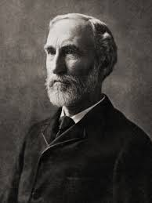

J Willard Gibbs

3.1 Vector point function

If each value of a scalar variable t, three corresponds a value of a vector , then is called a vector function of the scalar variable t and it is written as , 

Consider a vector  where  are called the components of the vector f(t) along the co-ordinate axes and they are function of a real variable t and  denote unit vectors along the axis of x, y, z respectively.

Let  be a vector function of the scalar variable t. Let  be a small increment in t and  be the corresponding increment in .

Then 

So that 

And 

If  exits,

Then  and is called the derivative of  with respect to t and . is second derivative of  with respect to . Similarly, the higher order derivatives of with respect to t can be defined.

me useful results:

(i) If is a scalar function and is a vector function, then



(ii)  are scalar constants and  are vector   
 functions

(iii)   are vector functions.

(iv) .

(v)   are vector functions.

(vi)     
 are vector functions.

(vii) The magnitude of a vector function  is constant if and only if 

(viii) The direction of a non-zero vector function  is constant (fixed) if and only   
 if 

(ix) Let  be a constant vector(both magnitude and direction are fixed) function of   
 the scalar variable t, then .

3.1.1 Equation of a space curve

The position vector  is the vector equation of the curve C.

Let  be a vector function of the scalar variable t. Let , where the components x, y, z are function of t, then derivative of vector function in terms of its components .

3.1.2 Geometrical Interpretation of : Let  be the vector equation of a curve C in space. Let and  be the position vectors of two neighbouring points P and Q on the curve.

C

Q

P



 is directed along the chord PQ.

As ,  i.e., chord PQ tends

tangent to the curve at P.

 is a vector along the

tangent to the curve at P or tangent

vector. If A be any point on the curve

C and AP=S then , therefore . In this case  will be a vector along the tangent at P. Also 

Thus,  is the unit vector along the tangent at P.

3.1.3 Velocity and Acceleration

The position vector  is the position of a particle P,  is the displacement of the particle in time . The vector  is the average velocity of the particle during the interval. If  denote the velocity of the particle at P, then  and its direction is along the tangent at P. If  be the change in velocity  during the time , then  is the average acceleration of the particle during the interval . If  represents the acceleration of the particle at P, then .

3.1.4 Tangent vector to the Space curve

Let  be the position vector of the space curve C at the point P(x, y, z), then the tangent vector to the curve at the point P is denoted by

 and the unit tangent vector is  .

3.1.5 Normal vector to the Space curve

The unit tangent vector  to the space curve at the point P(x, y, z).



Differentiating with respect to s, we get



Therefore  and  are orthogonal.  is the normal vector.

The unit normal vector to the space curve is 

3.1.6 Tangent and normal component of acceleration

Let  be the position vector of a moving particle at time t and let  be the acceleration and  be the velocity of a particle at P.

Here  is the tangential component and  is the normal component of acceleration

tangential component

And  



3.1.7 Points to be remember to solve the problems:

* If , then  is velocity and  is acceleration.
* The unit tangent vector is  and the unit normal vector to the curve is .
* If  and  are any two vectors and  is the angle between two vectors, then .
* Component of a vector  along a given vector  is .
* tangential component of the acceleration
* is the normal component of acceleration.

Problems:

1. A particle moves along the curve . Determine the   
 velocity and acceleration and their magnitudes at any time t at  (1999, 2003)

Solution: Let 



The velocity 

The acceleration 

At time t = 0,  

At time t = 0,  .

2. A particle moves along the curve , where a   
 is a constant. Find the components of the velocity and acceleration vectors at    
 along the vector .

Solution: Let 



The velocity 

The acceleration 

At time t = 1,  

At time t = 1,  

.

Let 



Component of a velocity  along a given vector  is 



Component of a acceleration  along a given vector  is





3. A particle moves along the curve . Determine its   
 velocity and acceleration. Also find the components of velocity and acceleration in the   
 direction of the vector  at . (VTU 1999, A 2002, F 2005)

Solution: Let 



The velocity 

The acceleration 

At time t = 2,  

At time t = 2,  

Let 



Component of a velocity  along a given vector  is





Component of a acceleration  along a given vector  is



.

3. A particle moves along the curve  Find the   
 components of velocity and acceleration in the direction of the vector    
 at . (VTU 2001, 2002, JA 2008, JU 2008,2016D, 2017J)

Solution: Let 



The velocity 

The acceleration 

At time t = 1,  

At time t = 1,  

Let 



Component of a velocity  along a given vector  is





Component of a acceleration  along a given vector  is



.

4. The position vector of a moving particle at time  is .Find the   
 tangential and normal components of its acceleration at  (VTU M 2001)

Solution: Let 



The velocity 

The acceleration 

At time t = 1,  

At time t = 1,  

The tangential component of the acceleration = 





The normal component of acceleration is =









5. Find the unit tangent vector and unit normal vector to the curve  and   
  at . (VTU JU 2006)

Solution: Let 



The velocity 

At time t = 0,  

The unit tangent vector is 



The unit tangent vector is  at t = 0,



But 





At time t = 0   


The unit normal vector to the curve is 

6. Find the unit tangent vector to the curve  at the points    
 Also, find the angle between these unit tangent vectors. (VTU AU 2001, JU 2010)

Solution: Let 



The tangent vector 

At time t = 1,  

At time t = -1,  

The unit tangent vector is 

The unit tangent vector is 

The angle between two unit tangent vectors,   




7. Find the unit tangent vector to the curve  (where  is a   
 constant) at the points  and . Also, find the angle between these unit tangent   
 vectors.

Solution: Let 



The tangent vector 

At time , 



At time , 



The angle between two unit tangent vectors,   




8. Find the angle between the tangents to the curve    
 at  and . (VTU JU 2006)

Solution: Let 



The tangent vector 

At time ,  

At time ,  

The angle between two unit tangent vectors,



9. A particle moves so that its position vector at time  is given by .   
 Where  is a constant. Show that the velocity  of the particle is perpendicular to    
 and that  is a constant vector.

Solution: Let 

Differentiate with respect to t we get



Consider, 



 Velocity vector  is perpendicular to .



 (constant)

10. If , where  are scalar constants, find and   
 , and prove the following: (i)  (ii) 

(iii) .

Solution: Given 

Differentiate with respect to t three times we get







(i) 



(ii) 









Squaring on both sides



(iii) 



.

11. If , where  is a constant scalar and  are constant   
 vectors, prove the following:(i) (ii)  (iii) 

Solution: Given 

Differentiate with respect to t we get





   
 



12. If  then show that . (VTU AU 2001)

Solution: Consider 

 



 and 





Exercise:

1. If , where n is a constant and t varies, show that 

2. Find the unit tangent vector and unit normal vector to the curve  at . Ans: 

3. Find the angle between the tangents to the curve Ans: 

4. A particle moves along the curve  where t is time. Find the components of its Velocity and acceleration at any time t and also their magnitude at t =0.

Ans: 

5. A particle moves along the curve , where t is time. Find the components of its Velocity and acceleration at time t = 1 in the direction . Ans: 

6. A particle moves so that its position vector is given by . Show that the velocity  of the particle is perpendicular  and  is a constant.

3.2 Scalar and Vector point functions

* A scalar which changes from one point to the other is called a scalar point function. (Also referred to as a scalar field.)
* A vector which changes from one point to the other is called a vector point function. (Also referred to as a vector field.)

The Vector Differential operator ‘Del’ or ‘Nabla’ is denoted by  and defined by

.

This operator is used to define gradient, divergence and curl. The operator is applied to both vector and scalar function.

3.2.1 Properties of gradient

* If f and g are scalar point function, then 

Or 

*  or 
*  or 

3.2.2 Gradient of a scalar

Let  be a given scalar field. Then the vector 

* Geometrical meaning of gradient  is along the normal to the surface at the point.
* If  and are the normal vectors to the surfaces then the angle between these two surfaces is .
* If , then the surfaces are said to intersect each other orthogonality.
* Unit normal to the surface S at the point  is 
* Directional derivative of  along  is 
* Directional derivative of  along  is 
* Maximum Directional derivative is  which is also called normal derivative.

1. Find  when  at the point . (VTU 2016D)

Solution: Given 

,  and 





At the point 







2. Find when  at the point .

Solution: Given 

,  and 





At the point 







3. Find a unit vector normal to the surface  at the point .

Solution: Given 

,  and 





At the point 











4. Find a unit vector normal to the surface  at the point .

Solution: Given 

,  and 





At the point 









5. Find a unit vector normal to the surface  at the point .

Solution: Given 

,  and 





At the point 









6. Find the angle between surfaces  and  at the point (2, -1, 2 ). (VTU 2017J)

Solution: Given 

,  and 





At the point 





Given 

,  and 





At the point 





The angle between the two surfaces is given by 



7. Find the angle between the normal’s to the surface  at the points (4, 1, 2) and .

Solution: Given surface is 

,  and 





At the point 





At the point 





The angle between the two surfaces is given by 



8. If  then show that  (iii) 

Solution: Given 





Differentiating partially w r to x, y and z, we get



we have, 





9. If then show that

Solution: Given





Differentiating partially w r to x, y and z, we get



we have, 







10. If then show that .

Solution: Given





Differentiating partially w r to x, y and z, we get



we have, 







Hence .

11. Find the directional derivative of  at the point  along the direction   
 .

Solution: Given surface is 

,  and 





At the point 



.

Consider, 



Directional derivative of  along  is 

12. Find the directional derivative of  at the point  along the direction   
 . (VTU 2017J)

Solution: Given surface is 

,  and 





At the point 



.

Consider, 



Directional derivative of  along  is 

13. Find the directional derivative of  at the point  along the direction   
 .

Solution: Given surface is 





and 





At the point 





Consider, 



Directional derivative of  along  is 

14. Find the directional derivative of the function  at the point  in the   
 direction of the line PQ where  In what direction it will be maximum? Find also the   
 magnitude of this maximum.

Solution: Given surface is 

;  and 





At the point 



Consider, 



Directional derivative of  along  is 



15. Find the directional derivative of the function  at the point  in the direction of   
 the tangent to the curve  where 

Solution: The equation of the curve is 







Unit tangent vector to the curve is 

Let the equation of the surface is 

;  and 





At the point 





Directional derivative of  along  is 





16. Find the directional derivative of the function  at the point  in the direction   
 of normal to the surface  at the point  Find also the magnitude of   
 this maximum.

Solution: Given surface is 

;  and 





At the point 





Consider the surface 

 ;  and 

Normal to the surface is 



at the point 







Directional derivative of  along the normal to the surface  is 



Maximum directional derivative of 



17. If the directional derivative of  at the point  has maximum   
 magnitude of 32 units in the direction parallel to y-axis, find .

Solution: Maximum directional derivative is along and in the direction parallel to y-axis and the magnitude is given by 32 units.

i.e.,  at the point (-1, 1, 2) (1)

we have, 







Now, 

 (using (1))



since  is parallel to y-axis, we must have 

Solving these equations, we get 

18. Find the directional derivative of  at the point .

Solution: Given surface is 

;  and 





At the point 





Directional derivative of  along  is 

19. Show that the surfaces  and  intersect orthogonally at the point   
 .

Solution: Given 

,  and 





At the point 



Given 

,  and 





At the point 





 The two surfaces are intersect orthogonally.

20. Find  such that the surfaces  and  intersect orthogonally   
 at the point .

Solution: Given 

,  and 





At the point 



Given 

,  and 





At the point 





Since the two surfaces intersect orthogonally we have 



 (1)

Also the surface  is passing through the point (1, -1, 2),



Substituting the value of b in (1), we get



.

21. If  is a constant vector and , prove that .

Solution: Given 

Let  be a constant vector, where  are constants

Now, 









Exercise:

1. If , Find . Ans: 

2. Find a unit vector normal to the surface at the point (-1, -1, 2). Ans: 

3. If , then show that 

4. Find the directional derivative of  at the point (2, -1, 1) along the direction .

Ans: -11/3

5. In what direction from (3, 1, -2) is the directional derivative of  maximum and what is its magnitude? Ans: 

6. Find the angle between the tangent planes to the surfaces at the point (1,1,1) Ans: 

3.3 Divergence and Curl of a vector point function:

* If  is a vector point function then divergence of  is



* If  then the vector is said to be Solenoidal vector.
* Physical interpretation of Divergence: If represents any physical quantity, then the divergence of  gives the rate at which the physical quantity is originating at that point per unit volume.
* Example:

(i) If ****represents the velocity of fluid flow then represents the rate of fluid flow through unit volume.

(ii) If represents the electric flux then  represents the amount of electric flux or heat flux that divergence per unit volume in unit time.

* .
* If  is a vector point function then curl of  is

 

* If the vector  is irrotational vector then 
* A vector field  is said to be conservative force field or curl free vector if 
* A vector point function  is said to be a conservative vector if there exists a scalar function  such that . Then  is called a scalar potential of .
* The curl of any vector point function will give the measure of the angular velocity at any point.

Note: The name “curl” was first suggested by James Clerk Maxwell in 1871.

1. Find the divergence and curl of the vector .

Solution: Let 

















2. Find the divergence and curl of the vector  at the point (2, -1, 1)

(VTU 2017J)

Solution: Let 







At point (2, -1, 1), 











At point (2, -1, 1), 



3. Find the divergence and curl of the vector  where .

Solution: Let 





















4. If , find the  and  at the point .

Solution: Let 





















5. If , find the  and  at the point .

Solution: Let 

   
 









At the point , 

















At the point ,



6. If , find the .

Solution: Let 



















7. If , find the  at 

Solution: Given 











At the point (2, -1, 0)





8. If , find  at .

Solution: Given 









At the point (1, -1, 1)



9. If , then show that .

Solution: 











10. Show that the vector  is solenoidal.

Solution: Given 

If the vector is solenoidal then .

We have, 





Hence is solenoidal.

11. If  and  then show that  is solenoidal. (VTU 2017J)

Solution: Given,  and 



If the vector is solenoidal then 

Now, 



Hence  is solenoidal.

12. If  is Solenoidal, find ‘a’.

Solution: Given  is Solenoidal



We have, 



.

13. If  is Solenoidal, find ‘a’. (VTU 2016D)

Solution: Given  is Solenoidal



We have, 



.

14. Show that the vector  is irrotational.

Solution: Given 

If the vector is irrotational then 

we have, 





 is irrotational.

15. A vector field is given by . Show that the field is irrotational and find the scalar potential. (VTU 2016D)

Solution: Given 





Therefore the given field is irrotational.

To find scalar potential given that 



Equating on both sides, we get ,  and 

Which gives ,  and 

,  and 



16. Show that the vector field given by  is irrotational and find the scalar potential .

Solution: Given 







Therefore the given field is irrotational.

To find scalar potential given that 



Equating corresponding components on both sides, we get

,  and 

Which gives ,  and 

,  and 



17. Find the constants ‘a’ and ‘b’ so that the vector  and find the scalar potential  such that .

Solution: Given  is irrotational.













Equating on both side, we get 



To find scalar potential given that 





Equating corresponding components on both sides, we get

,  and 

Which gives ,  and 

,  and 



18. Find the constants ‘a’, ‘b’ and ‘c’ so that the vector 

is irrotational.

Solution: Given is irrotational



   








Equating corresponding components on both sides, we get





19. Find the constants ‘a’, ‘b’ and ‘c’ so that the vector 

is irrotational. (VTU 2017J)

Solution: Given  is irrotational













Equating corresponding components on both sides, we get





21. Show that the vector is irrotational, where  and 

Solution: Given 





Differentiating partially w r to x, y and z, we get

 (1)

and 

If the vector is irrotational then 













3.4 Vector Identities

* 

Proof: Let  and 





Similarly 













* 

Solution: Let 



















or 

* 

Or 

Solution: Let  and 

























* 

Solution: Let 













*  (VTU 2017J)

Solution: Let 















 



* 

Solution: We have by the definition of the gradient of scalar











* (VTU 2016D)

Solution: Let 







Exercise:

1. If  then find . Ans: 18

2. If  then find . Ans: 0

3. If  is solenoidal, find ‘a’ Ans: a = 2

4. If  then find  at the point (1, 1, 1). Ans: 0

5. If  then show that is irrotational. Ans: 18

6. Show that the vector field  is both Solenoidal and irrotational. Also find the scalar potential . Ans: 

7. Find the constants a, b and c if the vector is irrotational, where  Ans: a = 1, b = 3, c = 3

8. For any vector , Prove the following :

(i)  (ii)  (iii) 

(iv) 